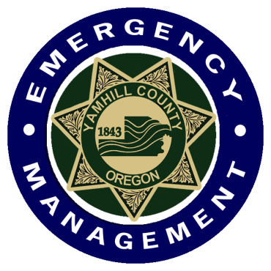

Yamhill County

Community Emergency Response Team

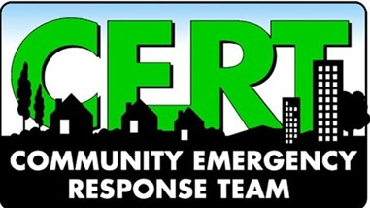

Policies and Procedures
Manual

“Doing the greatest good for the greatest number of people”

The February 19, 2023, edition of the
Yamhill County CERT Policies and Procedures Manual supersedes all previous editions:
April 2011
February 2014
September 2014

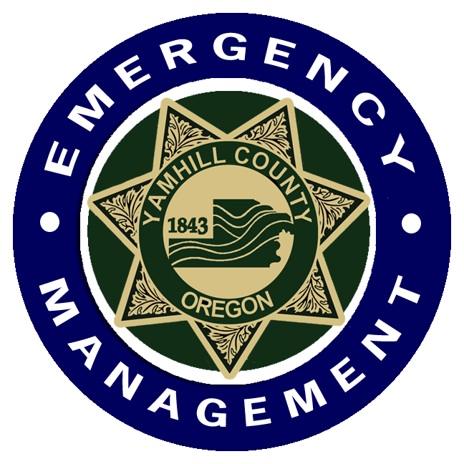
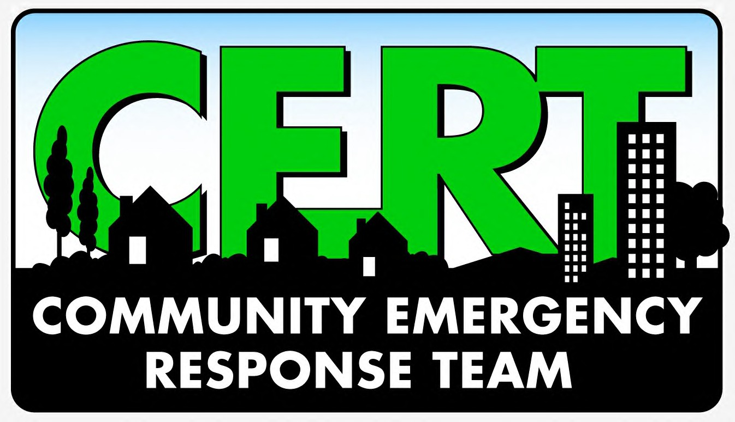

TABLE OF CONTENTS

YAMHILL COUNTY CERT
Mission Statement 5
Motto 5
CERT Academy 5

YC CERT MEMBERSHIP
How do I Get Involved? 7
CERT Volunteer Qualifications 7
Qualified CERT Volunteer Responsibilities 8
Transferring to Yamhill County CERT 8

POLICIES & PROCEDURES
Yamhill County CERT Policies and Procedures 9
Yamhill County CERT Volunteer Hours Policy 11
Activation Policies and Procedures 13
Yamhill County CERT Uniform Policy 14

YAMHILL COUNTY CERT ORGANIZATION
Yamhill County CERT Organization Chart 15
CERT Leadership 16
Elections 16
Elected Positions 16
Meetings 17
Leadership Committee 17
Appointed Positions 18
Committees 19

Continued, next page
OTHER
CERT Net 20
CERT Monthly Training 20
Yamhill County CERT Association 501c3 20
YCSO Incident Response Team 21

APPENDICES
Appendix I – Radio Communication Options 23
Appendix II – Glossary 25

ACKNOWLEDGEMENT OF RECEIPT
Acknowledgement of Receipt 27

YAMHILL COUNTY CERT

Mission Statement

Our mission is to provide volunteer support to Yamhill County Emergency Management organization in an ongoing effort to raise the level of citizen and business preparedness, and to make our community more Disaster Resilient through training and participation.

Motto
Doing the greatest good for the greatest number of people in the shortest amount of time using the least number of resources.

CERT Academy

Yamhill County CERT (YC CERT) Academy uses FEMA’s CERT Basic Training course curriculum. YC CERT endeavors to hold at least 2 academies per calendar year in various locations throughout Yamhill County. Students take the 9-week course and must participate in a simulated exercise to use the skills learned in the Academy. Participants that successfully complete the requirements will receive a Certificate of Completion and a CERT T-shirt. Students that are not able to complete the requirements by the last class will receive a Certificate of Participation. Once the requirements have been met a Certificate of Completion will be issued.

1. Disaster Preparedness
2. Disaster Medical Operations 1
3. Disaster Medical Operations 2
4. CERT Organization
5. Disaster Psychology
6. Terrorism Awareness
7. Fire Suppression and Utility Control
8. Light Search and Rescue
9. Radio Communications
10. Final Exam
11. Demonstration of personal 72-hour kit
12. Participate in class drill

In addition to these classes students must complete 3 online FEMA courses. In order to take the courses students must first apply for a FEMA Student Identification number (SID). Use this link to register for a FEMA SID, https://cdp.dhs.gov/femasid

IS-100.c Introduction to the Incident Command System. Takes approximately 2 hours to complete, https://training.fema.gov/is/courseoverview.aspx?code=is-100.c&lang=en

ICS-200.c Basic Incident Command System for Initial Response. Takes approximately 4 hours to complete, https://training.fema.gov/is/courseoverview.aspx?code=is-100.c&lang=en

IS-700.b Introduction to the National Incident Management System. Takes approximately 3.5 hours to complete, https://training.fema.gov/is/courseoverview.aspx?code=IS-700.b&lang=en

YC CERT MEMBERSHIP

How do I get involved?

Yamhill County has adopted an open entry policy. Applications are accepted from individuals throughout the county. Scan this QR code to complete the online application:

Or you may visit the county website at, www.co.yamhill.or.us,
- Under “Departments” select “Sheriff”.
- On the right-side menu under “General Information” select “Volunteers”.
- Select the “Volunteer/Internship Application” link that appears in the second paragraph.

In addition to the knowledge gained from CERT training, by studying together volunteer trainees will develop the important skills necessary to work as a cohesive team. The skills and knowledge gained in CERT training will serve you well in an emergency situation and your example may serve to encourage your neighbors or co-workers to become members of a CERT.

You may also qualify to serve in one of several designated volunteer jobs assisting at the Yamhill County Emergency Operations Center when it activates.

CERT Volunteer Qualifications

To be a qualified CERT volunteer you must have completed the following:
- Be a minimum of 14 years of age.
- Successfully complete all modules of the FEMA CERT Basic Training program (CERT Academy).
- Participate in fire suppression training.
- Build and demonstrate a personal 72-hour kit.
- Participate in the final class drill and written exam.
- Comply with the rules and policies set forth by the Yamhill County CERT Policies & Procedures Manual.
- Complete FEMA online study courses: IS-100, IS-200, and IS-700.
- Complete the online volunteer application.
- Submit and pass a basic background check.
- Be photographed and fingerprinted by the Yamhill County Sheriff’s Office.
- Complete and sign the Yamhill County Office of Emergency Management Volunteer Agreement.
- Complete Criminal Justice Information Systems (CJIS) online training
Volunteers have six (6) months from the end of the training program to complete all requirements.

*You must register on the FEMA website for a FEMA Student Identification (SID) Number in order to take these classes. Information may be found at https://cdp.dhs.gov/femasid

Qualified* CERT Volunteer Responsibilities

*Qualified CERTs are volunteers that are current with all requirements.

What are the Responsibilities to Maintain My Status as a Qualified CERT Volunteer?

- Maintain yourself and your own household in a state of readiness so that you can effectively respond to events in your neighborhood and serve as an example to others.
- Attend no less than 8 hours of approved training each year.
- Provide personal profile data and keep it current in VicNet.
- Maintain personal and organizational equipment in good condition.
- Participate in at least one drill every two years.
- There is an expectation that you commit to participating in no less than one community awareness event per year (Yamhill County Fair, National Night Out, Newberg Old Fashioned Festival, Cruising McMinnville, etc).
- Upon termination of membership or change in active status you must promptly return CERT-issued equipment, PPE and surrender your ID card.
- Always conduct yourself in an appropriate manner.
- Complete CJIS training every 2 years.
- Enter all CERT volunteer hours you performed into VicNet or VicTouch no later than the 5th of the following month in which those hours were performed.
- Report VicNet/VicTouch errors to CERT Timekeeper promptly.

Only members who have been issued an identification card are eligible for deployment during and following a major emergency or disaster. Members with Trainee identification cards must be accompanied by a CERT Field Training Officer in order to participate in deployments. There will be no exceptions to this policy.

Yamhill County CERT Volunteers are covered by the Yamhill County Workers Compensation Insurance during deployment, training, and other approved events.

Transferring to Yamhill County CERT

What if I was an active CERT in another jurisdiction and I want to join Yamhill County CERT?

- Contact the Program Chair.
- Chair will contact the other CERT organization to verify your status and level of training.
- If you were designated as “archived” status or inactive for more than one year you must retake the basic training program (CERT Academy) and complete the qualifications outlined previously in this manual.

POLICIES & PROCEDURES

Yamhill County CERT Policies and Procedures:

- CERT teams shall promote and comply with the policies, procedures and operating philosophies of Yamhill County Emergency Management.

- CERT-trained individuals and/or teams, while serving or representing CERT, shall operate within the parameters of the CERT training.

- CERT-trained individuals and/or teams, while serving or representing CERT, shall not self-deploy.

- CERT volunteers are responsible for maintaining all CERT equipment and resources in clean and operable condition. All equipment shall be used strictly in a manner consistent with their training, and shall not be transferred, sold or disposed of without prior authorization from the CERT Program Chair or Yamhill County Emergency Manager.

- Any request by another locality, other counties, or another state, to Yamhill County for CERT resources (whether for disaster, emergency, special event, and/or training, etc.) shall be authorized and coordinated through Yamhill County Emergency Management or the Yamhill County Sheriff’s Office. Deployment of CERT-trained individuals and/or teams outside of Yamhill County, while serving or representing CERT, shall be based solely on mission-specific tasks.

- CERT volunteers will provide timely notification of changes in contact information (address, email, phone, etc.) to the CERT Program Chair, CERT Membership Coordinator, AND Yamhill County Sheriff’s Office Volunteer Coordinator.

- CERT volunteers must display their CERT ID cards at all times while performing duties in any official CERT capacity.

- CERT volunteers are individually responsible for communicating their own personal limitations.

- The CERT Program Chair(s), Vice-Chair(s), Team Lead or Incident Commander must be notified as soon as possible of any injury, regardless of whether it requires medical attention. An investigation of the incident will be conducted to determine if safety procedures were adequate, communicated clearly, and complied with at the time of incident.

- CERT teams cannot allow any individual who is not a qualified CERT volunteer to be included in official CERT deployments. This does not exclude spontaneous volunteers from being utilized for non-CERT tasks.

Yamhill County CERT Policies and Procedures, continued

- Failure of CERT volunteers or teams to comply with the policies and procedures as stated may result in their immediate termination from the Yamhill County CERT Program.

- Any illegal or improper conduct on the part of any member may be cause for termination from the program. The decision of the Yamhill County Emergency Manager will be final.

- CERT volunteers should conduct themselves within the scope of their CERT training during volunteer service at community events, all events and deployments directly related to the Yamhill County Sheriff’s Office, and at all other times while wearing CERT apparel (hat, shirt, vest, jacket, coat).

- CERT volunteers must submit volunteer hours into VicNet by the 5th of the following month in which those hours were performed or else forfeit those hours.

- CERT volunteers agree to attend at least 4 monthly trainings per year.

- CERT volunteers agree to adhere to the Uniform standards set forth in this manual.

- CERT volunteers must comply with the Yamhill County CERT Social Media policy as outlined below.

“The purpose of the Social Media presence of Yamhill County CERT on any Social Media platform is intended to promote the organization, inform the public and membership of Yamhill County CERT’s activities, items of interest related to Emergency Preparedness, and community-related events. Posts that are shared to the platform will be vetted for truthfulness or removed immediately if found to be untrue.”

- CERT volunteers agree to follow the Volunteer Hours Policy outlined in this manual.

Failure to comply with these policies and procedures could tarnish the reputation of the organization; endanger the public, CERT volunteers, and emergency responders; could expose Yamhill County to liability; could result in the loss of resources needed to respond to emergency events; and could jeopardize the eligibility of Yamhill County to receive federal and state funding needed to support the CERT program.

Yamhill County CERT Volunteer Hours Policy

The Yamhill County Sheriff’s Office uses the Volgistics programs, VicNet and VicTouch for logging volunteer hours. It is YC CERT’s policy that volunteers report their own hours into the VicNet or VicTouch program. When you receive your volunteer ID badge, you will be issued a login name (your email address you used in your Volunteer Application) and temporary password to access your hours.
- It is a YC CERT requirement that you record your volunteer hours performed on behalf of the organization.

- Get in the habit of tracking your hours for all CERT events. It is helpful to carry a small notebook where you can record the hours or use your smartphone’s calendar or Notes feature.

- Remember to sign in and out of all YCSO CERT events on the appropriate sign in/out sheets. This is physical proof that you were at the event/incident and assists the Team Leader in accounting for all volunteers in case of an emergency.

- You may claim the travel time separately to get to and from these events as long as it is door-to-door. Do not include time you spent stopping for a beverage and similar instances.

- Do not claim hours if you’ve already claimed them for another volunteer organization, even if it’s a non-Yamhill County organization. No “double dipping”.

- Do not record volunteer hours that:
- Are also part of your professional training or Continuing Education (CE) credits.
- Training in which you are reimbursed for your time and travel expenses.

- Events, seminars or webinars that you attend must be available to the public unless approved my CERT leadership.

- Other training hours may be allowed if permission is requested BEFORE the event.

- If there is a question, send an email to the Program Chair(s) BEFORE the event and get approval.

- Report your hours by the 5th of the following month in which the hours were performed.

- Report all of your hours – even if you signed in on a sign in sheet.

- Sign in to VicNet and check your hours regularly.

- Members of the Incident Response Team (IRT) may claim 5 hours per month.
Yamhill County CERT Volunteer Hours Policy, continued

- CERT volunteers must maintain their own record of details pertaining to volunteer hours claimed in VicNet/VicTouch. At times, the CERT Timekeeper may have questions regarding an entry. You must be able to provide details on what you did. You should track:
- Date (s) of hours being reported: 10-12-2019
- Time In/Time Out 1300-1600 hours (use 24-hour format)
- Number of hours for the event: 3 hours
- What you did? How does it benefit CERT? Training: Mental Health First
Aid for Adults – it provided me with a better of understanding of how to assist someone having a mental health crises similar to what was taught in the CERT Disaster Psych module.

- The YC CERT fiscal year is October 1st through September 30th of the following year. All CERT hours must be submitted each month by the 5th of the following month. Volunteer hours performed from September 1th through September 30th must be reported by October 5th in order to be eligible for that fiscal year’s Presidential Service Award. NO EXCEPTIONS.
- To receive an award, you must be an active YC CERT volunteer at the time the awards are issued.

Presidential Volunteer Service Awards

Adult (26+) Presidential Volunteer Service Award hours are awarded as follows:
Between 100 and 249 hours = Bronze Award
Between 250 and 400 hours = Silver Award
More than 500 hours = Gold Award

Young Adult (16-25) Presidential Volunteer Service Award hours are awarded as follows:
Between 100 and 174 hours = Bronze Award
Between 175 and 249 hours = Silver Award
More than 250 hours = Gold Award

Teen (11-15) Presidential Volunteer Service Award hours are awarded as follows:
Between 50 and 74 hours = Bronze Award
Between 75 and 99 hours = Silver Award
More than 100 hours = Gold Award

CERT Certificates of Appreciation

CERT Appreciation Certificates are awarded as follows:
9-19 hours = Bronze Certificate
20-49 hours = Silver Certificate
50+ hours = Gold Certificate

Activation Policies and Procedures

When activated, CERT volunteers and teams become part of the Yamhill County Sheriff’s Office Incident Command System.

CERT may be placed on ‘standby’ or ‘active’ duty by the Yamhill County Sheriff’s Office Emergency Manager or Incident Response Team (IRT) Team Lead, who will implement the ‘call out’ protocol. This may be in the form of text message, email, phone, and/or the use of radio. All CERT volunteers are expected to read the call out information in its entirety and reply to the request for volunteers as they are able.

Yamhill County CERT Uniform Policy

CERT uniform includes:
- CERT T-shirt
- CERT cap
- CERT vest
- County ID badge
- CERT outerwear, if you have it
- CERT helmet, if required
At community events or deployments CERTs must wear their ID badge, CERT shirt, or CERT vest at all times with khaki pants, black pants or blue jeans in good condition. Clothing should be clean with no holes, tears or wrinkles. Khaki, black or denim shorts are acceptable, but they must be no shorter than 2 inches above the knee. Closed-toe shoes are required for all deployments.

CERTs are expected to arrive on time and ready to volunteer. Typical duty bags should include a minimum of:
- Flashlight with extra batteries (powerful enough for use outside in dark conditions)
- Hydration bottle with enough water for 12 hours
- Energy food (for up to 12 hours)
- Whistle
- Small first aid kit for personal use
- Notepad with pen/pencil (preferably something that won’t smear or run when wet)
- Pocket knife or multi-tool
- Clipboard
- Notebook/Binder (include radio call list, phone #s, maps, markers, P&P)
- Sunscreen
- Ear protection
- Eye protection (sunglasses)
- Gloves (work gloves & nitrile)
- Appropriate clothing, footwear and outerwear for the season/weather
- Anything you would need for the next 4-12 hours
- Fully charged CERT radio, if you bought one for personal use
Optional:
- Lip balm
- Bug repellent
- Tissues, wipes
- Hand sanitizer
- Multi-tool
- Garbage bag, 30-gallon (2)
- Earphone (small earphone with 1/8” mono jack for radios)

YAMHILL COUNTY CERT ORGANIZATION

Yamhill County CERT Organization Chart
Yamhill County Sheriff’s Office

Office of Emergency Management

Volunteer Coordinator
Emergency Manager (CERT Liaison)

YCSO Events Coordinator
Yamhill County CERT Program Leadership

Yamhill County CERT Assn., Inc. 501(c)(3)

Program Chair(s)*

Vice-Chair(s)*
Membership Chair(s)*

Membership Secretary*
Field Training Officers**
Events Liaison**
Timekeeper/
Volgistics **

Appointed Committees, Coordinators and Liaisons***
Medical & Safety Officer (VC)
Training Committee (VC)

FEMA-Trained CERT Instructors
Medics

Social Committee (M)
Logistics
Coordinator (C)
General Membership

CERT Academy Liaison (C)

*Elected positions
Communications Coordinator (C)
**Appointed positions
***Appointed committees are chaired
Membership Retention (M)
by the elected leader noted in
parenthesis next to the committee’s name
Public Relations (C)
CERT Net Control Manager

Note: All members are encouraged to serve on a committee. Only active members in good standing who have met all the basic requirements for membership may serve in an elected capacity.

CERT Leadership

Elections

- Chair & Membership Chair terms expire in even years; Vice-Chair & Membership Secretary terms expire in odd years. In the event where there are co-positions the term expirations will occur in alternate years (position 1 in even years; position 2 in odd years).
- Nominations for elected positions which are due to expire are held annually in December.
- Nominations are submitted to the Volunteer Coordinator who then contacts the nominated volunteer to find out if they will accept the nomination.
- Voting takes place anonymously in late December.
- The Volunteer Coordinator tabulates the ballots.
- Election results are announced at the January meeting.
- Newly elected leaders begin their 2-year term at the February meeting.

Elected Positions
The description of the elected positions below is not intended to be a complete list of duties. It is a concise representation of typical duties performed.

When an office position is shared (co-positions) the terms will alternate in even and odd years.

Chair(s)
- Reports to Emergency Manager and Volunteer Coordinator.
- Elected for two-year term in even-number years.
- Oversees day-to-day operations of YC CERT.
- Oversees the leadership team and committees as noted in CERT Organization Chart.
- Lead representative of CERT to other organizations and agencies.
- Liaison to Yamhill County Emergency Management.
- Submits Detailed Authorization Forms (DAF) for each community event, in which CERT volunteers participate, to the Yamhill County Volunteer Coordinator (including non-YCSO events where CERT volunteers are used – even in a non-CERT capacity.)
- If licensed as an amateur radio operator, acts as CERT liaison to Yamhill County Amateur Radio Emergency Service. Otherwise, appoints a qualified member of leadership to act as liaison.

Vice-Chair(s)
- Reports to Chair.
- Elected for two-year term in odd-number years.
- Stands in for Chair (or Co-Chair) when Chair is unavailable.
- Schedules leadership meetings.
- Facilitates leadership meetings.
- Coordinates the organization calendar of events and training.
- May submit DAFs on behalf of the CERT Chair.

Membership Chair
- Reports to Chair.
- Elected for two-year term in odd-number years.
- Pre-requisite of two years experience in another YC CERT election position.
- Maintains membership records and contact information.
- Maintains all email distribution lists (may be delegated).
- Maintains membership roster of qualified* CERTs.
- Timekeeper for logging volunteer hours (or this role may be designated).
- Coordinates events in which CERT volunteers are asked to participate.
- Coordinates online signups for events (may be delegated).
- Responsible for assigning a Team Lead for CERT-attended events if not noted on the Detail Authorization Form (DAF).
- Responsible for providing event and incident Shift Team Lead with roster of names and mobile numbers.
- Responsible for making sure that everyone signs in/out at events and incidents. The sign in sheets must be given to the CERT Timekeeper immediately.
*Qualified CERTs are volunteers that are current with all requirements.

Membership Secretary
- Reports to Membership Chair.
- Elected for two-year term in even-number years.
- Takes notes at all Leadership Committee meetings.

Meetings:
The CERT program leadership will meet at least 4 times per year to conduct meetings. The schedule and agenda will be set by the Vice-Chair.

Leadership Committee
The Leadership Committee consists of Elected and Appointed Positions that meet on a regular basis.
- The Program Chair, or Vice-Chair in Program Chair’s absence, oversees this committee.
- The Vice-Chair sets the agenda for Leadership Committee meetings.
- All appointed positions are members of the Leadership Committee as described below.
- Appointed positions and committees are not required to attend Leadership Committee meetings unless an item on the agenda requires their presence.
- The Leadership Committee determines the direction of the membership:
  - Which events we participate in
  - Which training will be provided
  - Scheduling CERT Academy courses

Appointed Positions

Field Training Officer (FTO)
- Reports to Vice-Chair.
- FTOs are seasoned CERT volunteers appointed by elected CERT leadership and report to the Vice-Chair.
- FTOs provide field training to CERT Trainees who have not yet met all the requirements or have not yet passed their background check due to administrative backlog by the state.

CERT Academy Liaison
- Reports to Chair.
- Facilitates the administration of the Academy once the dates, facility and instructors are scheduled.

Communications Coordinator
- Reports to Chair.
- Maintains custody of records and inventories of available communications equipment.
- Develops and maintains the CERT Communications Plan form to be used for activities.
- Ensures the Communication Plan is used for every event or activity.

Medical and Safety Officer
- Reports to Vice-Chair.
Requirements:
- Possesses a current adult, infant and child first-aid, CPR and AED certificate or above (classes and credentialing are not provided by YC CERT).
Duties:
- Updates and maintains a CERT medical response kit.
- Forwards records of medical credentials to Membership Chair.
- Prepares a safety message for each activity.
- Notifies members of critical updates and available training.
- Ensures the team kit is at all events and activities.

Logistics Coordinator
Requirements:
- Reports to Chair.
- Basic proficiency with Excel spreadsheets is helpful.

Duties:
- Maintains inventory of all CERT and CERT-used, Yamhill County-owned equipment.
- Maintains an in-out log.
- Prepares requests for inventory replenishment.
- Maintains inventory of CERT trailer and makes sure it is stocked.
- Maintains inventory of CERT storage at Lafayette Community Center.
- Maintains inventory of CERT storage at Yamhill County Fairgrounds.

Events Liaison
- Reports to the Membership Chair.
- Provides information for online signups.
- Seeks out events and opportunities in our region for us to participate in such as city, county, and community service events, flu shot clinics, etc.
- Develops a list of items needed for each event, i.e., canopy, tables, chairs, signs, handouts/flyers, etc. Make sure that the necessary items get to the events.

Committees

Training Committee
- Reports to Vice-Chair.
- Must have CERT Train-the-Trainer certificate.
- Selects topic for monthly training.
- Organizes training. Finds guest speakers, if necessary, make sure necessary materials are available.
- Ensures supplies necessary for training are available.
- Conducts training.
- Ensures all training rosters and certificates are turned into the Membership Chair.

Social Committee
- Reports to Membership Chair.
- Helps organize the annual CERT banquet.
- Schedules and organizes CERT group social events such as but limited to, an annual Fall Potluck Dinner, Spring Picnic, movie night, etc. Secures the sites for these events and organizes what members need to bring – food categories, paper supplies, etc.
- Coordinates with Events Coordinator to organize volunteers and potluck.

Membership Retention Committee
- Reports to Membership Chair.
- Develops a questionnaire to ask members what their suggestions are for improvement in our program, get to know the people in our group, what are their interests, how can we get them more involved, etc.

Public Relations Committee
- Reports to Chair.
- Develops new recruiting materials, handouts, and brochures, etc., to be used at public meetings, information booths and recruiting events.
- Schedules events for recruiting new members.
- Social media liaison.
- Provides approved news releases and articles, newspaper announcements regarding upcoming classes/training.
- Coordinates with other CERT committees to accomplish these tasks as necessary.
- Any and all information that goes out must be approved by the elected leadership BEFORE publication or distribution.

OTHER

CERT Net
- Reports to Communications Coordinator.
- The purpose of the CERT net is for CERT volunteers to practice and become familiar with proper radio communications.
- The net is an on-the-air meeting.
- The nets are led by a Net Control Manager, simply referred to as Net Control.
- The Net Control Manager is assigned by the Communications Coordinator.
- CERT volunteers use their county radio identification number on the net’s commercial frequency.
- CERT nets are not conducted on amateur radio frequencies. However, in the event it becomes necessary to use an amateur radio frequency only CERTs with FCC call signs may participate.

CERT Monthly Training
- Meetings are held monthly on the 3rd Monday of the month.
- Meeting agenda is set by Vice-Chair.
- CERT volunteers are encouraged to attend all monthly meetings to maintain their skills.

Yamhill County CERT Association 501(c)(3) Role

Yamhill County CERT Association, Inc. is a 501(c)(3) nonprofit corporation.
- It is the financial arm of the YC CERT organization.
- Functions as the primary source of fundraising for the CERT organization.
- Subject to change, the 501(c)(3) board meets four times a year on the third Thursday of October, January, April, and July.
- The 501(c)(3) board of directors make decisions on how to raise and spend money.
- Officer positions, President, Vice-President, Secretary and Treasurer, are elected amongst the board of directors for two-year terms.
- Elected CERT leadership (Chair, Vice-Chair, Membership Chair, Membership Secretary, may not hold elected officer positions on the 501(c)(3) board.
- 501(c)(3) officers may not hold an elected leadership position for Yamhill County CERT while serving as an officer of the 501(c)(3).
YCSO Incident Response Team (IRT)
- A team of qualified Yamhill County Sheriff’s Office volunteers from the six volunteer units who are available to help on very short notice, typically via phone or text messaging.
- Consists of:
  - Team Lead
  - Team Coordinator(s)
  - Team Members
- CERT Volunteers interested in becoming IRT volunteers must have the recommendation of the CERT Chair(s) or Vice-Chair(s).

This page intentionally left blank
Appendix I –

RADIO COMMUNICATION OPTIONS

CERT Radios
YC CERT maintains a supply of radios for use at events by its members. The use of these radios is governed by the Yamhill County CERT Radio Protocols described below.

Yamhill County CERT Radio Protocols
- BEFORE using, make sure you are on the correct channel/frequency.
- Make sure the radio is turned ON and appropriately connected.
- Hold the radio straight with the antenna upright.
- Think about what you’re going to say, press the Press-To-Talk (PTT) button, take a breath then speak. Always state the unit being called first, then the calling unit, “Team Lead, 782”
- Engage in necessary yet BRIEF conversation.
- Speak clearly, using plain language – no codes.
- Do not broadcast names, personal information, particulars about those we help, or background music.
- Use the Yamhill County Radio Operator number assigned to you.

County Tactical Radios
These radios are maintained at the Sheriff’s Office and Emergency Management. Operators must use their Yamhill County Radio Operator number for identification. These radios are used on incidents to communicate with Yamhill County Communications (YCOM) and between law enforcement. Only those that have completed the County Radio Class are eligible to use these radios.

Yamhill County CERT Tactical Radio Protocols
- You must receive Tactical Radio training before using a tactical radio.
- BEFORE using, make sure you are on the correct channel/frequency.
- Make sure the radio is turned ON and appropriately connected.
- Hold the radio straight with the antenna upright.
- Think about what you’re going to say, press the Press-To-Talk (PTT) button, take a breath then speak. Always state the unit being called first, then the calling unit, “YCOM, 782”
- Engage in necessary yet BRIEF conversation.
- Speak clearly, using plain language – no codes.
- Do not broadcast names, personal information, particulars about those we help, or background music.
- Use the Yamhill County Radio Operator number assigned to you.

RADIO COMMUNICATION OPTIONS, continued

Amateur Radio Emergency Services (ARES) and Radio Amateur Civil Emergency Services (RACES)
The Yamhill County ARES/RACES point of contact will also serve as the CERT Communications Coordinator at the Yamhill County Emergency Operations Center in the event of activation. During times of disaster, CERT operators will communicate with the ARES/RACES operator at the Emergency Operations Center. ARES/RACES volunteers are not necessarily CERT members.

Appendix II –
GLOSSARY

This glossary is a helpful guide of commonly used abbreviations in the Yamhill County CERT program. It is not intended to be all-inclusive.

9-1-1: The emergency number to call in Yamhill County
(503) 434-6500: Yamhill County Communication “YCOM” Non-
Emergency Phone #

ABC: Airway, Breathing, Circulation
ADA: Americans with Disabilities Act
AFN: Access and Functional Needs
ARC: American Red Cross
ARES: Amateur Radio Emergency Service
BSI: Bodily Substance Isolation
CERT: Community Emergency Response Team
CERT Net: An on-the-air meeting of qualified CERT volunteers
DAF: Detail Authorization Form
DHS: Department of Homeland Security
DOGAMI: Department Of Geology and Mineral Industries
(Oregon)
Duty Bag: A bag containing supplies the volunteer may need for
the next 12 operational hours
EM: Emergency Management
EMR: Emergency Medical Responder
EMS: Emergency Medical Services
EOC: Emergency Operations Center
Event: A planned occasion or activity
FEMA: Federal Emergency Management Agency
FRS: Family Radio Service radios
FSE: Full Scale Exercise
FTO: Field Training Officer
GMRS General Mobile Radio Service
Go-Bag: A bag containing supplies for emergency response
ICS: Incident Command System
Incident: An unplanned event
IRT: Incident Response Team
KSA: Knowledge, Skills, Abilities
MRC: Medical Reserve Corps
NGO: Non-governmental Organization
NIMS: National Incident Management System
NRF: National Response Framework
OHA: Oregon Health Authority
Expanded Glossary, continued

OEM: Oregon Emergency Management
OSHA: Occupational Safety & Health Administration
P&P: Policies and Procedures
PDA: Preliminary Damage Assessment
PIO: Public Information Officer
POC: Point of Contact
PPE: Personal protective equipment
RACES: Radio Amateur Civil Emergency Services
RPM: Respirations, pulse, mental status; used in triage
SAR: Search and Rescue
SMART: Specific, Measurable, Achievable, Relevant, Time-
Oriented
SME: Subject Matter Expert
SO: Sheriff’s Office
SOG: Standard Operating Guide
SOP: Standard Operating Procedure
START: Simple Triage and Rapid Treatment
SUG: Sign Up Genius
VIPS: Volunteers in Police Service
VOAD: Volunteer Organizations Active in Disaster
VRU: Volunteer Response Unit
YCA: Yamhill County Auditorium
YC CERT: Yamhill County Community Emergency Response Team
YCOEM: Yamhill County Office of Emergency Management
YCOM: Yamhill County Communications (dispatch)
YCSO: Yamhill County Sheriff’s Office
`
Acknowledgement of Receipt

I hereby acknowledge receipt of the Community Emergency Response Team (CERT) Policies and Procedures Manual for Yamhill County, Oregon, revised February 19, 2023.

Name:
(Please Print)

Signature: Date:

